**Case Study**

**Profile of M/s Sri Datta Sai Shilpa Industries**

|  |  |
| --- | --- |
| **Name of the Enterprise** | M/s Sri Datta Sai Shilpa Industries |
| **Udyog Aadhaar/SSI Registration No.** | TS06B0002471 |
| **GST** | 36ACPFS2067L1Z1 |
| **Line of activity** | Manufacturing of BOPP (Biaxially Oriented Polypropylene Films), LD (Low Density Polyethylene), Laminated Poly films for packaging FMCG products and other goods |
| **Factory Address** | Plot. No 289/A, Pashamylaram Phase III, Patancheru |
| **Registered office Address** | H.No.3-5-592, Vittalwadi, Himayatnagar, Hyderabad - 500029 |
| **Establishment year** | 2016 |
| **Constitution** | Partnership Firm |
| **Details of Partners/Directors/Proprietor and their age** | Mr. Dadiga Sudeep, Age- 32  Mrs. Dadiga Udaya Kantha Kumari, Age- 60 |
| **Primary Lender** | APSFC |

Though APSFC sanctioned Rs.220lakhs in the year 2016, commercial production did not start. By the end of August 2019, the total loan disbursed was ₹155.00 lakhs only. The moratorium period has ended in the month of May 2019. From September 2019, SFC stopped disbursing pending amount of ₹65.00 lakhs due to some internal issues in their organization. By the end of October 2019, total construction was completed.

There were extra costs incurred by the entrepreneur due to delay in release of funds. This has resulted in shortage of margin money to be contributed by the borrower for disbursal towards balance machineries. Due to delay in release of funds, entrepreneur was not able to start commercial production as the remaining machineries of Laminating and Cutting & Slitting are held up by the supplier. Enterprise was under severe stress consequently, even though entrepreneur had put in all efforts for implementation of the project. Enterprise was suffering ab initio sickness due to internal issues of lending organization which are extraneous to the enterprise.

Preliminary visit to the unit and discussions with the SFC officials revealed that the problems and stress are real and are beyond the solution from SFC. However, they were prepared for a resolution if the TIHCL proposed one. At this point, TIHCL started its diagnosis.

The Diagnostics:

1. **Line of Activity:**

Entrepreneur engaged in manufacturing of Manufacturing of BOPP (Biaxially Oriented Polypropylene Films), LD (Low Density Polyethylene), Laminated Poly films for packaging FMCG products and other goods. The finished products are used in Foods packaging such as chips packets, Shampoo sachets etc.,

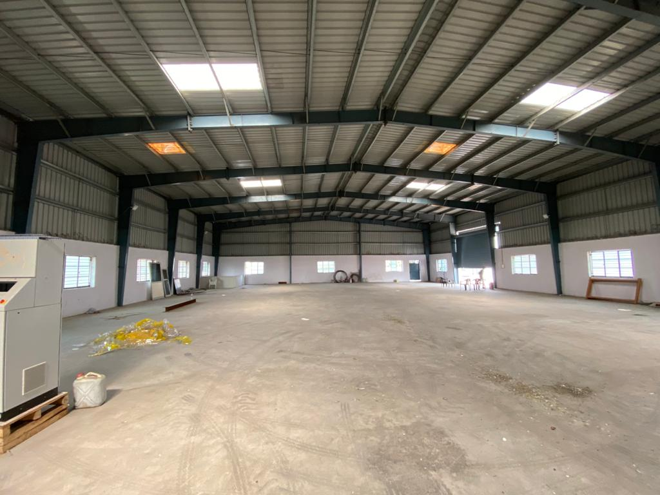

1. **Location of the Unit:**

The location of the Unit is in Pashamylaram village, SangaReddy District (earlier Medak Dist). Unit is located in Industrial area hence availability of experienced and trained personnel is available in the area. Transportation and other logistics are convenient.

1. **Machinery:**

Civil works are completed. Constructed shed by using quality Essar brand material over an area of 2400 yards. Quality check lab also constructed. All the machinery equipment (printing, laminating, and cutting) has been installed in the unit and entrepreneur also engaged 5 employees. The machinery is from a reputed brand Rotoflex Industries.

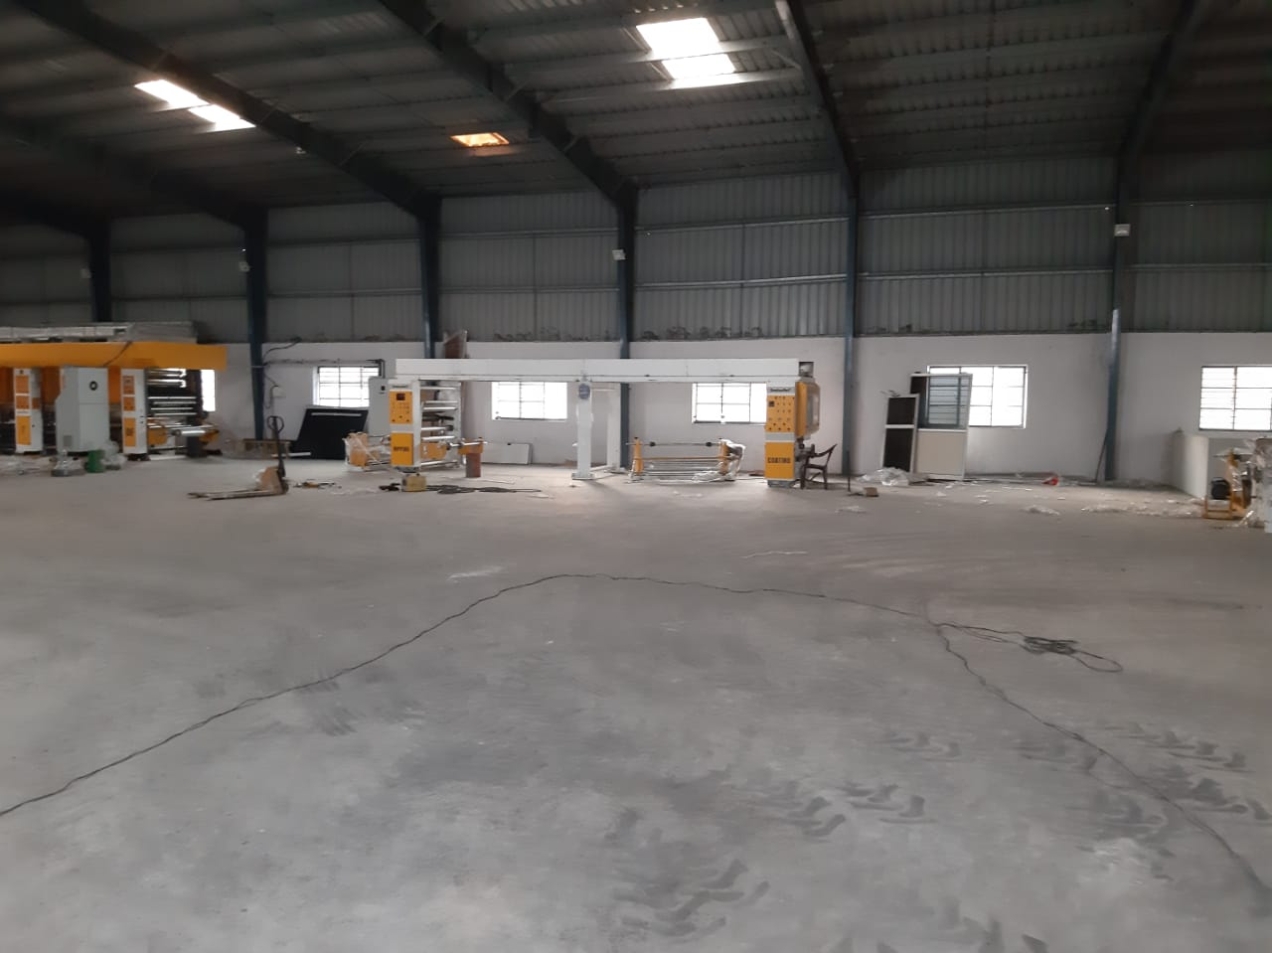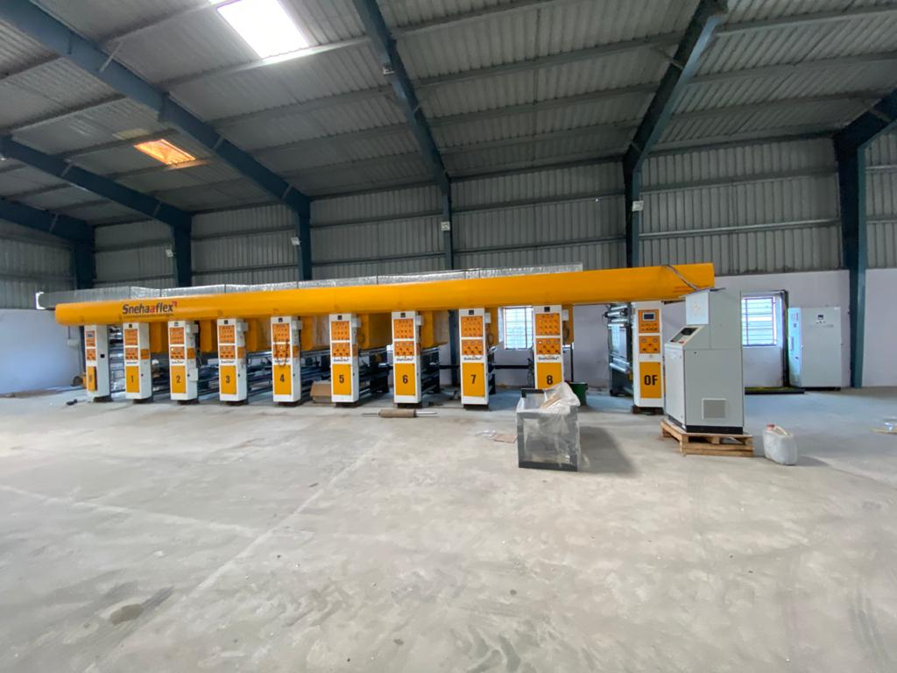

**M/S Sri Datta Sai Shilpa Industries**

1. **Manufacturing Process:**

There are three machineries which are Printing, Laminating and Cutting. First, the raw material which is BOPP or LD film rolls are placed on printing machinery. Once the label is printed on the film, then it moves to second step called laminating. The printed roll will be placed on laminating machine so that the film gets thickness and improvisation. Then the final step is cutting the rolls in required dimensions as mentioned by the buyers. These sheets are then kept for quality checkup and then for dispatch.

* **Managerial Competencies and Family Details and their impact on business:**

The constitution of establishment is partnership consisting himself and his mother Mrs. D Udaya who is a housewife. He has two siblings one elder brother and one younger sister. His brother is also a businessman in Real Estate Sector. His sister is married and lives in USA. His family is ready to support him to make his business successful. There was a positive impact of his family on his business as there was a continuous support whenever he faced the issues during the establishment of the unit.

* **Inspiration for starting the Enterprise:**

Entrepreneur Mr. Sudeep Dadiga is an MBA postgraduate aged 32 years. He worked as investment banker in an MNC for 5 years. Over a period he resigned his job to start trading of non-woven bags to understand the business. Later with support of his family he entered trading of Non-Woven bags and gained knowledge and experience of 4 years in trading and manufacturing of plastic packaging industry. Further, with prior experience and his hard-earned money, he established manufacturing unit of poly films by loan facility from APSFC in the year 2016. Here the sole inspiration for setting up of the enterprise was prior experience in the similar line of the activity and secondly, moral, and financial support from his uncle.

* **First Lender for support and why was it preferred?**

Entrepreneur initially approached APSFC for the financial support for setting up of the unit. As the entrepreneur was not much aware of the other banks or financing institutions, he preferred APSFC on the suggestion of one of his relatives.

* **Timeline for availing credit:**

The prescribed timelines of the primary lender as per sanctioned document for release of total amount was 1½ year from the date of sanctioning the loan but it took more than 3 years to release the sanctioned amount. Here, the loan of ₹220 lakhs was sanctioned in the year 2016 and till date only ₹190 lakhs were released.

* **Entrepreneur’s awareness and assessment of market in the field:**
* He is self-marketing his product and getting orders from known customers.
* He also planning to register on GEM and other marketing platforms.
* Enterprise has good potential in domestic market in Telangana State
* There is good demand for the product from food processing, fertilizers and FMCG sector.
* **Expenses incurred from hand till the final disbursement and approvals for starting the production:**
* **Details of other loans:**

In this case, there are no outside loans as the customer borne all the expenses by his hard-earned money.

* **Who suggested TIHCL? or Reference:**

One of the branch managers of APSFC has referred the unit to TIHCL for the revival assistance.

* **Responses and Support from TIHCL:**

TIHCL has diagnosed the enterprise and identified following reasons of sickness

* Delay in disbursement of sanctioned amount
* Incomplete financial closure by the primary lender
* Additional amount brought in by the firm for completion of civil works due to partial release of funds which caused financial stress on firm.
* Installation of partial machinery restricting the firm to enter commercial production.
* **How TIHCL addressed the concerns:**
* As per TIHCL resolution package, SFC (Primary lender) had released pending term loan of ₹27 lakhs and extended moratorium of 1 year. TIHCL provided margin loan of ₹24 lakhs in addition to SFC loan for release of machinery which is a total of ₹51 lakhs. Further, the pending machinery of laminating and cutting was installed in the unit and ready to start commercial production.

**Labor Status: (post TIHCL intervention)**

|  |  |  |
| --- | --- | --- |
| Gender | Skilled | Unskilled |
| Men | 1 | 4 |
| Women | 0 | 0 |
| Total | 1 | 4 |

**Livelihood:** Enterprise created employment to 5 workers at 50% of capacity and may require another 5 to 6 workers during full capacity**.**

* **Confidence on TIHCL:**

Entrepreneur is very much confident of TIHCL support now and in future. After TIHCL intervention, unit has acquired full machinery and started trial run as well, which was pending since last one year before his approach to the TIHCL.

Regarding working capital, the unit has been guided to register with SIDBI that has a special scheme for SC/ST and women entrepreneurs. SIDBI would in all likelihood consider the sanction expeditiously because of the sponsorship of TIHCL.